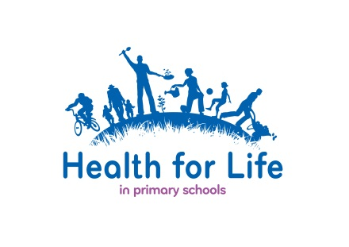

Ref: Photographs and Mondelēz International Release Forms

I have included below, an example letter which you may wish to send requesting parent’s permission for their child’s photo to be used in connection with the Health for Life in primary schools programme. The Mondelēz International release form may be sent with this. We have found, from experience, that some parents find the form rather formal and an accompanying letter helps to explain why it is necessary. The letter may obviously be adapted to suit but the form itself must remain unaltered.

Example Letter

Dear

Ref: Photographic Permission

As you may be aware, the school has been taking part in the Health for Life in primary school programme which is sponsored by Mondelēz International. As part of the project, pupils were recently / are to be involved in a ………… event / session in school and photographs were / will be taken of the various activities. Health for Life in primary school would like to use a selection of these photos to showcase how schools have participated in the programme. Photos may be used to illustrate reports, the Health for Life in primary school website and displays about the programme.

In order to ensure that you are happy with this arrangement, Mondelēz International have requested your signed permission. To confirm that you are willing for your child’s photo to be used, please would you sign the enclosed form and return it to the school secretary by ……(date)………..

Yours sincerely

………………
Head teacher

Enc. Mondelēz International Personal Release Form

