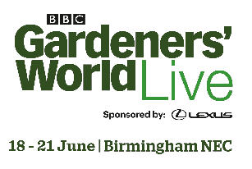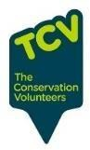

SCHOOL WHEELBARROWCOMPETITION

APPLICATION FORM

Please complete this application form to confirm that your school plans to enter the School Wheelbarrow competition at BBC Gardeners’ World Live.
Please return completed forms to lucy.tremlett@riverstreetevents.co.uk by 28th February 2020 if your school would like to take part. If you have any queries, please feel free to call Lucy on 0207 150 5130. NOTE that due to the nature of this competition (specifically the collection/delivery of barrows) it is open to schools in the Midlands, UK, only.

School name
Address, including postcode (this will be used for collection and returning the wheelbarrow. Midlands, UK, only)
Tick as appropriate | - Infant □ Primary □ Secondary
Contact name #1 Email
Phone
Contact name #2 Email
Phone

Key timings
- This application form – return by 28th February to lucy.tremlett@riverstreetevents.co.uk
- Briefing session – Thursday 5th March, 4 – 5pm, at Winterbourne House and Garden, with collection of barrows and compost
- Plant list – by 1st May to lucy.tremlett@riverstreetevents.co.uk
- Barrow collection – 15th – 17th June, from the address detailed above
- Winners presentation – 21st June at BBC Gardeners’ World Live
- Show dates – 18th to 21st June 2020
- Barrows returned – 22nd – 25th June, to the address detailed above

Using the details supplied above, we’ll keep in touch re key dates, tickets to the show, signage and plant list requests, and any other details as they arise.

Thank you and good luck!
From the BBC Gardeners’ World Live team

