Brass Central Ensemble Audition Technical Exercises
This page is for Brass Attack and Training Wind Orchestra
for Trombone, Euphonium, Baritone, Tuba
1. On the mouthpiece buzz any note.
(Aim to make the best sound you can and hold the pitch steady for about five seconds)

2. Take the mouthpiece away from your lips, then replace it and try to buzz the same note you just played.

3. Still using just the mouthpiece, buzz a glissando up and down.

4. From memory, play the scale of C major (F major for Tuba), one octave, up and down.
Play it once staccato and once legato.

5. Tonguing exercise to be played no slower than 76 bpm (Tuba to play b.1-4 only)

6. Lip slur exercise to be played no slower than 76 bpm

Euphonium/Baritone/Trombone
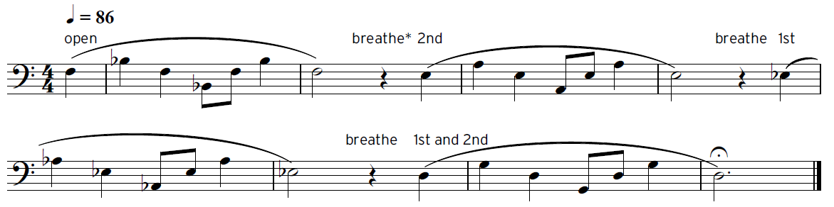

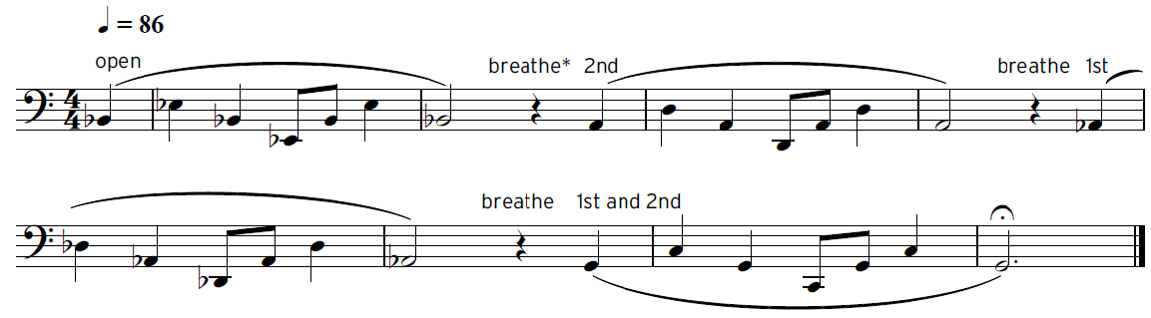
Tuba

In addition to this sheet please prepare the following repertoire:
Brass Attack: The Nuthatch – Easy Jazzy Tudes
Training Wind Orchestra: James Bond Theme – p19 Easy Winners

