Brass Central Ensemble Audition Technical Exercises

This page is for Brass Attack and Training Wind Orchestra for French Horn

1. On the mouthpiece buzz any note.
(Aim to make the best sound you can and hold the pitch steady for about 5 seconds)

2. Take the mouthpiece away from your lips, then replace it and try to buzz the same note you just played.

3. Still using just the mouthpiece, buzz a glissando up and down.

- Play from memory the scale of D major, one octave, up and down.
Play it once tongued and once slurred.

5. Tonguing exercise to be played no slower than 76 bpm
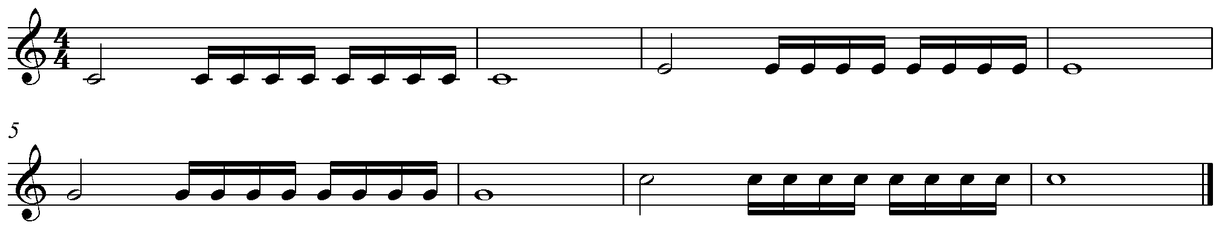

6. Lip slur exercise

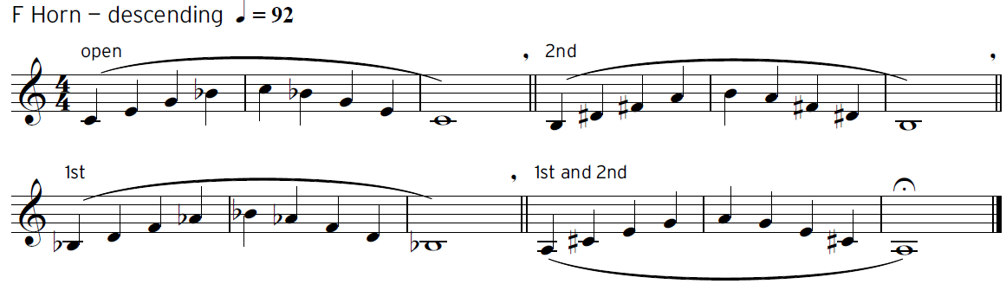
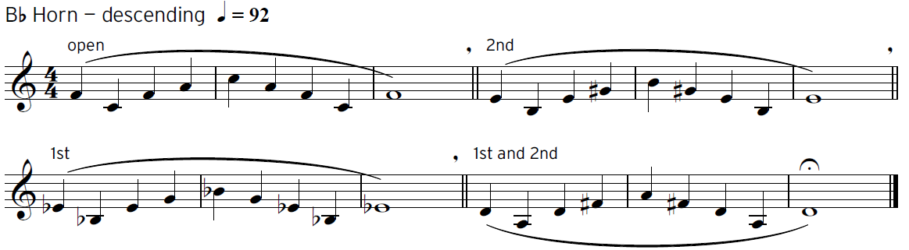

In addition to this sheet please prepare the following repertoire:
Brass Attack: The Nuthatch – Easy Jazzy Tudes
Training Wind Orchestra: James Bond Theme – p19 Easy Winners

