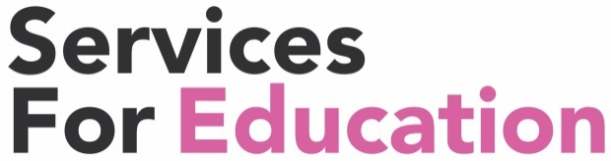

Brass Central Ensemble audition technical exercises

This page is for Brass Attack and Training Wind Orchestra

for Trumpet, Cornet, Tenor Horn, Baritone, Trombone, Euphonium, Trombone or Tuba

1. On the mouthpiece buzz any note.
(Aim to make the best sound you can and hold the pitch steady for about 5 seconds)

2. Take the mouthpiece away from your lips, then replace it and try to buzz the same note you just played.

3. Still using just the mouthpiece, buzz a glissando up and down.

4. Play from memory a scale of D major, one octave, up and down. Play it once staccato and once legato.

5. Tonguing exercise (to be played no slower than 76 bpm)
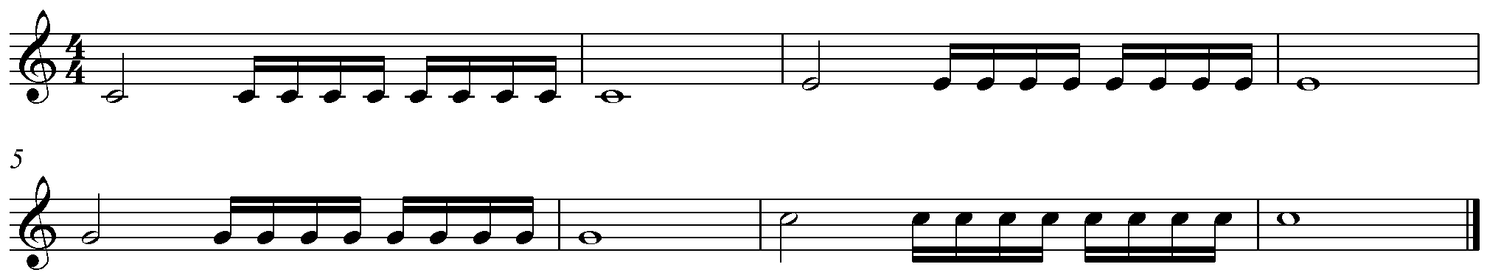

6.Lip slur exercise (to be played no slower than 76 bpm)
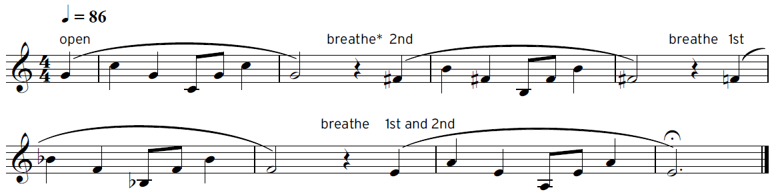

In addition to this sheet please prepare the following repertoire:
Brass Attack: The Nuthatch – Easy Jazzy Tudes
Training Wind Orchestra: James Bond Theme – p19 Easy Winners

